History of GB

History of GB 1

Before that: Iberians

80BC to 43AD Celts
- Tribes
- Gaelic languages
  - Still present
    - Galeic (Scotland)
    - Welsh
    - Irish
  - Local names - The Avon, Dover

43AD - 400 AD Romans
- Emperor Claudius
  - Pushed the Celts into
    - W - Wales
    - N - Scotland
  - Education, Religion (Christianity)
  - Sanitation, Roads, Trade
  - Hadrian Wall
    - Built - N
    - Protection
  - Cities, Towns - Bath
    - Worchester, Leicester
      - Castra = Military camp

407 - 1066 Anglo-Saxons
- Tribes
  - Angles
  - Saxons
  - Jutes
- 7 Kingdoms
  - Sussex
  - Wessex
  - Essex
  - Kent
  - East Anglia
  - Northumbria
  - Mercia

800 Vikings/Danes
- Attacks from N
- Like americans during black friday, but the stores are villages and the discount is 100%

829 AS kingdoms - united
- 1st king Eubert

879 - 901 King Alfred the Great
- Educated
- Read, Write, Latin
- Wrote a chronicle
- Peace with the Vikings
  - For money
  - Danelaw
    - Subscription fee for peace

1017 - 1035 Viking king in England
- Canute, CNut, Knut

1035 AS back on the English throne
- King
  - Edward the Confessor
    - As a child hiding in Normandy
      - Duke of normandy was promised to become the king of England

1066 Edward died without ab heir
- AS nobility chose Harold as their king
X
- William, Duke of Normandy
1066 - Battle of hastings
- Harolds army was injured from wars with the vikings
- William attacked
- The war was a stalemate for the first two days
- Fake retreat prank
- Harold died
  - Church
- William the Conqueror
  - King
  - Seat in London
  - Built the Tower of London
- AS speaking people + French speking nobility
  - Modern English

1337 - 1453 100 years' war
- England x France
- French won

1350 Black death
- 1/2 og the people died
  - Shortage of manpower
- Selfdom + Feudalism
  - Collapsed
- Sheep farming -> Trade

1455-1487 The war of two Roses
- Yorks - White
X
- Lancaster - Red

1485 Tudors on the throne

History of GB 2
- Henry VIII
  - 6 wives

1534 - Reformation/Church of England
- Wanted to break up with wife (Latina(Spanish))
  - Pope said no
  - Oops, accidentally made a new religion
- Accidentally made the church mad (^^')
- Reporting hidden catholics to grab their wealth
  - Like agar.io

Elizabeth I (Virgin queen)
- Defeated the Spanish fleet
- Pirates
- Died without an Heir
  - Skill Issue
- Stuarts on the throne - Scotland
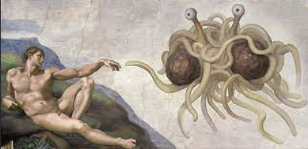

James the I(VI in Scotland)
- Scotland x England
- Catholics x Protestants
- Absolute king x Parliament
- Feudalism x Capitalism
Copy
- James I - Compromise -> His son
- Charles I - Starts civil war
King x Parliament
- Landed aristocracy x Bourgeoisie
- Church of England
- Stronger in the N x Stronger in the S
- Soldiers - Cavaliers x Roundheads
Group of puritans prevail
Leader Oliver Cromwell
Reorganised Parlament army
Ranks by experience
Copy

1644 - Battle of Marston Moor
- Parliament won
- 1649 War ends
  - Charles I - Arrested + Executed

The Commonwealth 1649-1660
- Supposed to be a republic butt......
- Oops, missclick, abolished the parliament
- Oliver Cromwell
- Named himself "Lord Protector"
It was a Military dictatorship
- He was a puritan
  - He ruined all the fun

1660 - People not 'happy'
- Commonwealth collapsed
- Return to monarchy
- 1660-89 Restoration of Monarchy
- Charles II
  - Lesser power than before
- Parliament - Main power
- 2 parties
  - Whigs and Tories


James II - Glorious Revolution
- Tried to abolish the parliament
  - Become absolute monarch
  - Not enough supporters
- Parliament said NO and named William of Orange the king of England

Why will?
- From Nether Lands
  - Enemy of Spain
  - Protestant
  - Married to James's daughter
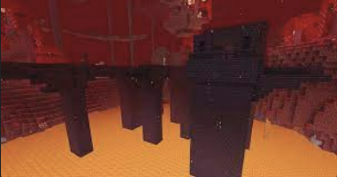

1689 - The Bill of Rights
- William of Orange signed
- Limitation of his powers
- No changes since then

Industrial revolution winners
- Had coal and Iron
- Were already capitalsim
  - Before 'murica


